RESEARCH ARTICLE

**TITLE: FORMULATION AND EVALUATION OF TOPICAL MICROEMULGEL FOR TREATMENT OF MELASMA**

Mahima A Mudhole,Harish* K.H., Dr. Fatima Sanjeri Dasankoppa,, Dr. AHM Vishwanath Swamy

Department of Pharmaceutics, KLE College of Pharmacy, Hubballi, Karnataka, India. AConstituent unit of KLE Academy of Higher Education and Research, Belagavi, Karnataka,India.

Corresponding Author:

Harish K.H.

Associate Professor

Department of Pharmaceutics

KLE College of Pharmacy, Hubballi

A constituent unit of KAHER, Belagavi

Email ID: [harikh79@gmail.com](mailto:harikh79@gmail.com)

Contact: 9986056174

**INTRODUCTION**

Topical drug delivery products can be broadly classified as either internal or external. While the internal topicals are given to the mucous membrane orally, vaginally, or on the rectal tissues for local activity, the exterior topicals are distributed, sprayed, or otherwise dispersed over the tissue to cover the diseased area. A topical drug delivery system's main benefits include preventing first-pass metabolism, preventing gastrointestinal incompatibilities, improving patient compliance, enabling simple self-medication, and allowing for the easy termination of medications as needed. Additionally, drugs with short half-lives and narrow therapeutic indices can also be used. [1]

The primary advantage of dermal application over alternative delivery routes, such as oral, sublingual, rectal, and parentral, is that it might be thought of as superior. Avoiding the first pass metabolism is the route. Many benefits come from applying medication topically, such as targeted and site-specific drug delivery. They make a substance more bioavailable. [1] Because topical drug delivery bypasses the gastrointestinal route, reduces unnecessary unpleasant effects by reaching the lesion directly, and avoids gastrointestinal irritation and the hepatic first-pass effect, it is frequently utilized in a variety of disorders. One of the body's most vital defense mechanisms, the skin aids the organism in defending itself against the vast majority of external threats. Nonetheless, a major hurdle to the efficacy of topical drugs is the skin's robust barrier function. [1] Numerous substances enter and leave the body through the skin, which also regulates body temperature and prevents moisture loss to maintain homeostasis.2,3 Skin conditions affect about one-third of the world's population and are the fourth leading cause of disease in humans.[2]

The topical route involves the administration of drugs in various morphologically structured tissues, such as the skin and mucosa, each with unique characteristics in cellular organization and membrane composition. To improve drug permeation, achieve appropriate drug concentrations at the site of action, and facilitate easy application, well-designed nanocarriers must be developed.   
All of the research included here examined patterns in the structural assessment of the skin and mucosa, the function of novel excipients as permeation enhancers, correlations between in vitro and in vivo processes, and drug administration using various nanocarriers and matrices. [3] Topically applied dermal products are divided into two groups: those that have systemic effects and those that have local effects.[4]

**MATERIALS AND METHODS**

**Chemicals**

Metformin HCL is the [API] methyl paraben is used as preservative ,glycerein ,HPMC and Xanthum gum is a natural gelling agent used for gel. Triethanolamine is used for maintaining Ph . Tweeb 80,span 20 and polyethylene glycol is used as surefactant and co-surefactant. Water for use of solvent. All chemicals and reagent used in the study of analytical balance.

**Apparatus**

Conical flask 50ml,burette,pipette 10ml,Glass beaker 50ml,100ml,1000ml,aluminium foil tube of 10ml.

**Instruments**

UV Visible spectrophotometer, Weighing balance, Magnetuc stirrer, Homogenizer, Brrookfield viscometer, USA Franz diffusion cell , Refrigerator , Incubator , waterbath , Sonicator and oven.

**Method**

Preparation of microemulsion by phase titration methodfor preparation psudo ternary diagram. Formulation of API loaded microemulgel using suitable design of expereinments.

**Methodology**

**Melting point**

Melting point of Metformin HCl was considered as a criterion for purity as well as for identification. Capillary melting point apparatus was used to determine melting point of Metformin HCl. Small amount of Metformin HCl was filled in the capillary and melting point was observed.

**Metformin HCL Caliberation curve in methanol[5]**

From the stock solution-aliquots of 2,4,6,8,10,12,and 14ml were taken from stock solution 2 in 10ml volumetric flask and diluted using methanol to get a concentration ranging from 2 to 14μ/mlwere prepared. Absorption of each solution was measured at λmax 249nm against methanol as reagent blank.

**FTIR Of Metformin HCL[6,7]**

Compatibility study of obtained sample of druspectrum and final formulation were analysed by FT-IR spectroscopy. The pellets were produced by utilizing KBr and the samples were examned in the ratio of 1:100 KBr. Preparaed pellets were analyzed for functional group frequencies of Metformin HCL and their combination respectively compared with that of original spectrum. FT-IR spectroscopy was examined to know the compatibility between the drug and excipients in order to produce a safe and efficacious formulation.

**Saturation solubility of drug, surfactant amd co-surfactant[8,9,10]**

Various natuarally occuring oils and synthetic oils were analyzed for Metformin HCL solubility to find out the best suitable oil for construction of pseudo ternary phase diagrams. To determine the ingredients needed to create microemulsions, the solubility of various surfactants and co-surfactants was also investigated.

An excess amount of Metformin HCL[400mg] was placed in stoppered capped vials containing 3ml of vehicle thats is oil [linseed oil], surfactant [Span 20, tween 80] and co-surfactant [PEG,PG] with the vehicles. Then vials vials were shaken using a mechanical rotary shaker for 72hrs at 370C. After attaining equilibrium conditions, the vials were centrifuged at 5000rpm for 15min, using centrifuge to obyain a clear supernatant liquid. Then the supernatant was collected and extracted for Metformin HCL.

**Development of pseudo ternary diagram by using phase titration method[11,12]**

Linseed oil, lemon oil and olive oil was selected as oil phase from solubilities studies. Tween 80 and polyethylene glycol was selected as surfactant and co-surfacrtant respectively. Tween 80 was selected also on the basis of HLB value which is 15 and suitable for o/w formulation. Surfactant and Co-surfactant were mixed [Smix] in 1:2, 2:1, 3:1 and 4:1 ratios. For each phase diagram, oil and Smix at specific ratio were mixed thoroughly in vortex mixer to give oil : Smix at different ratio from 9:1 to 1:9 ratio. Each mixture was titrated with water and visual observation was made transparent o/w microemulsion. End point for the titration was turbid appearance of mixture. From findings of water titration method pseudoternary phase diagram was constructed with one axis representing aqueous phase, oil and surfactant and co-surfactant. The software CHEMIX School 7.00 was used to create pseudo-ternary diagrams. The component percentages were computed and shown on the phase diagram for pseudo-ternaries. A line was drawn connecting the points to demarcate the clear and turbid regions.

**Phase titration table for [1:,2:1and 3:1][13,14,15]**

|  |  |  |
| --- | --- | --- |
| **OIL:SMIX RATIO** | **SMIX %** | **WATER[SOLVENT%]** |
| F1 10 | 39 | 51 |
| F2 10 | 42 | 48 |
| F3 10 | 40 | 50 |
| F4 10 | 41 | 49 |
| F5 10 | 42 | 48 |
| F6 15 | 40 | 45 |
| F7 10 | 39 | 51 |
| F8 10 | 50 | 40 |
| F9 15 | 45 | 40 |

**Formulation and development of blank microemulsion[16,17]**

The o/w microemulsion area was determined and the ratio of the surfactant and cosurfactant was chosen from the pseudo-ternary phase diagrams. The component ratios at which the microemulsions were prepared, i.e. Oil: 5–30%, Smix: 30-65%, and water: 35–65%.   
Continuous magnetic stirring was used to combine the surfactant, cosurfactant, and oil in which the medication had the highest solubility. To create a transparent microemulsion, fresh deionized water was added drop by drop to this homogeneous mixture and well stirred for 30 minutes. After that, the formulations were assessed.

Table 2[16,17]

|  |  |  |  |
| --- | --- | --- | --- |
| **SL NO.** | **INGREDIENTS** | **QUANTITY** | **FUNCTIONS** |
| 1 | HPMC | 0.75g | Gelling agent |
| 2 | Linseed oil | 10ml | oil |
| 3 | Tween 80 | 1.7ml | Emulsifier |
| 4 | PEG | 1.7ml | Emulsifier |
| 5 | Polyethylene glycol | 5ml | Humectant |
| 6 | Sodium benzoate | 0.6g | Preservative |
| 7 | water | Q.s | Vehicle |

**Formulation of Metformin loaded microemulsions[13,14,15]**

The preparation and stability assessment of the blank microemulsions came first. The medication was then added to stable blank formulations to create microemulsions. To make the medication-containing microemulsions, precisely weighed etoricoxib was dissolved in room-temperature oil and Smix. This mixture was stirred continuously at room temperature while water was added drop by drop. With light magnetic stirring, the micro-emulsions were given 30 minutes to acclimatise. The microemulsions that had formed were then assessed a day later.   
Table lists the microemulsion compositions tabulated.

**Evaluation of blank and Metformin loaded microemulsions[18,19,20]**

Clarity and appearance, as well as quantitative tests , % transmittance, viscosity, pH, and centrifugation, were assessed for the blank and drug-loaded formulations. Zeta potential, polydispersity, droplet size, and drug content of formulations loaded with drugs were also assessed. In each test, the outcomes were recorded in triplicate, with the average being taken into account. The microemulsions that were created were assessed visually for colour, homogeneity, consistency, and physical changes including preciptation and phase separation.

By measuring the % transmittance of the prepared microemulsions at 650 nm using an ultraviolet-visible spectrophotometer with distilled water as the blank, the optical clarity of the microemulsions was ascertained. In the same way, the diluted microemulsions' percent transmittance was tested at 10, 100, and 1000 times with the continuous phase.   
With the use of a Brookfield® viscometer (DVE, Brookfield, USA), the viscosity was determined. After being dipped in the microemulsion, spindle number 62 was rotated at room temperature at a speed of 20 revolutions per minute.   
A calibrated digital pH (1010, Esico, India) metre was used to measure the pH of the drug-loaded microemulsions at room temperature.

In a 10 mL volumetric flask, a microemulsion corresponding to 10 mg of Metformin HCL was added, and methanol was used as the extraction solvent. Methanol was added to the capacity to get it up to 10 mL. After an appropriate dilution, the absorbance of the solution was measured at 235 nm using a UV-visible spectrophotometer, allowing the drug's concentration to be computed. After centrifuging the microemulsions for 10 minutes at room temperature at 5000 rpm, the systems were visually inspected for creaming and phase separation.

A Zetasizer zen 3600 particle size analyzer was used to measure the droplet size, polydispersity index, and zeta potential of the microemulsions. The device is located in Malvern, UK.

**Preparation of optimized microemulsion based gel of Metformin HCL**

|  |  |  |  |
| --- | --- | --- | --- |
| **Ingredients** | **MEG-1[W/W%]** | **MEG-2[W/W%]** | **MEG-3[W/W%]** |
| Metformin HCL | 0.1 | 0.1 | 0.1 |
| Linseed oil | 15 | 15 | 15 |
| Smix[tween 80&PEG400] | 40 | 40 | 40 |
| HPMC | 1 | 1.5 | 2 |
| Sodium benzoate | qs | qs | qs |
| Water | 45 | 45 | 45 |

**Characterization of Metformin HCL containing ME based gels:**

1. **Physical Appearance**

The produced formulations of gellified microemulsions were examined to determine their colour, uniformity, consistency and pH. One percent aqueous pH solutions of the prepared microemulsion that has gelled are as determined by a pH metre.

1. **Spreadability measurement[21]**

Spreadability study was done using two glass sides of length 8cm. 350gm of microemulgel was weighed accurately and it was on one glass slide was weighed accuratelyand it ws taken on a glass slide. Another glass slide was gradually placed above it from a height of about 5cm. A weight of about 5gm was placed on the upper glass slide.After 1 min, measure of the circle that was spread was noted in cm. The observed diameter is a measure which designates the type of gel formed.

1. **Rheological study[22]**

The gel's viscosity dependent on microemulsion formulation was measured with a brook at 370C. field viscometer (Viscometer Brookfield DV-E). At different rpm, 62 TL4 number spindles were configured. The viscosity measrement was repeated in triplicate and average readings were taken for standard deviation.

1. **Drug content studies[23][24]**

Take a 1g gel based was taken in 10ml volumetric flask containing 5ml methaanol and subjected to sonication for 15min. To get a clear solution, filter it. Utilising a UV spectrophotometer at 249nm, find its absorbance. The same solvent is used to prepare the drug's standard plot. The same standard plot can be used to calculate concentration and drug content by entering the absorbance value.

1. **pH[23,26]**

Using a digital pH metre, the pH of a 1% water solution of the microemulsion-based gel was determined.

1. **In-vitro prmeation study[23,27,24]**

The in-vitro permeation study of microemulgel and marketed gel[Metformin HCL] was carried out with the help of franz diffusion cell using dialysis membrane. The membrane was soaked in phosphate buffer pH 7.4 prioe to the study for 24hrs and carefuuly mouted in between the donor and receptor compartment. Microemulgel equivalent to 10mg of MET was spread umiformly on the dialysis membrane. 12.5 ml of pH 7.4 phosphate buffer was used as a dissolution media which was placed in the receptor compartment. The donor compartments were kept in contact with receptor compartment. The whole assembly was kept on magnetic stirrer and the solution on the receptor sde was stired continously using magnetic bead and set up was maintained at a temperature of 37±0.5℃.At specific time intervals,smaples of 1ml were pipetted out in series of volumetric flasks and replaced back with the same mount of fresh buffer solution. This investigation was done for 7hrs. Samples at different time intervals were analysed by UV Spectrophotometer at 249nm and the amount of drug permeated was determined.

**Preparation of 7.4 pH phosphate buffe**r: 250ml of 0.2 M pottasium dihydrogen ortho phosphate solution was taken in 1000ml flask and 195.5ml of 0.2M sodium hydroxide solution was added. Then the volume was made up to mark with dist water.

**Drug kinetic study**:

The kinetic release rate mechanism from microemulgel formulation details procured from in-vitro diffusion study was examined by plotting the best suitable model for drug release data in zero order , first order, and korsmeyer-peppas graphs. By using microsoft excel software, the release rate for all the models were identified by linear regression. The best sitable model of precision regression coefficient[R2] was used for evaluation.

**Zero order kinetic model**: Dissolution of drug from pharmaceutical dosage forms don’t break down, drug releases in a slow manner by assuming that there is no change in the area and equilibrium condition can be obtained zero order rate release models were suitable according to the following formula.

Cumalative % drug released against time.

**First order kinetics** : This model can be used to study release rate data and first order kinetic model was suitable according to the following formula;

Log of % Drug to be permeated against time.

**Higuchi Kinetics release rate** : This release mechanisms can be studied for drugs which are soluble in water and insoluble drugs that absorb in solid, semisolid matrices. Data obtained from higuchi model were best fitted for following formula.

Cumalative % Drug released against square root of time.

**Results:**

**Melting point determination**

The melting point determination was performed to check the purity of drug. The melting point of the Metformin HCL was found to the range 223-224˚C, which complies with the standard i.e., 223-226˚C.

**UV spectrum of Metformin HCL**

|  |  |  |
| --- | --- | --- |
| SL NO. | CONCENTRATION[μgm/ml] | ABSORBANCE[nm]AT 249 |
| 1 | 0.2 | 0.164 |
| 2 | 0.4 | 0.283 |
| 3 | 0.6 | 0.459 |
| 4 | 0.8 | 0.643 |
| 5 | 1 | 0.709 |
| 6 | 1.2 | 0.845 |

**Compatability studies using FTIR**

**FTIR spectrum of pure drug**

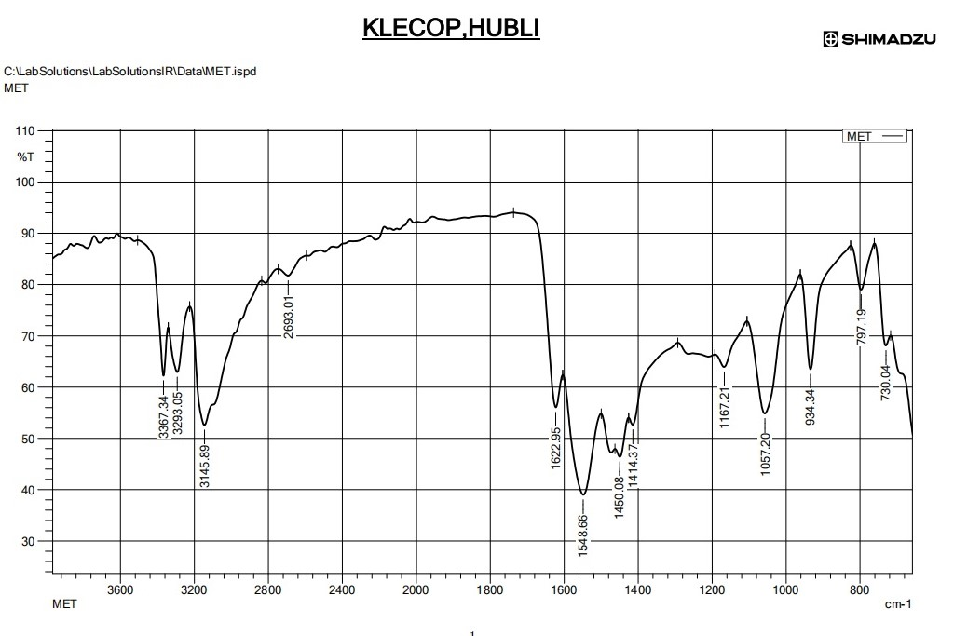

Data obtained from FTIR spectral peaks

|  |  |
| --- | --- |
| Wave no. [cm-1] | Functional group or bond |
| 3200-3600 | O-H streching [alcohol] |
| 3100-3000 | O-H streching [alkanes] |
| 1700-1600 | C=O streching[carbonyl] |
| 1560-1500 | N-H bending [amines] |
| 1450 | C-H bending [methylene] |
| 1250-1100 | C-N streching [amine] |
| 1000-900 | C-O streching [alcohol or ether] |
| 850-750 | C-H bending [aromatic] |

FTIR Spectrum of formulation

**Solubilties studies**

|  |  |  |
| --- | --- | --- |
| **Phase type** | **Excipient** | **Solubility** |
| Oil | Linseed oil | 0.64 |
|  |  |  |
| Surfactants | Tween 80 | 23.8 |
|  | Span 20 | 16.4 |
|  |  |  |
| Co Surfactants | PG | 10.2 |
|  | PEG 400 | 12.7 |

**Contruction of pseudo-ternary diagrams**

**Chemix diagrams**

**Evaluation of prepared microemulsions**

|  |  |  |  |
| --- | --- | --- | --- |
| **Formulation code** | **pH** | **%Transmittance at 650nm** | **Viscosity** |
| F1 | 7.2 | 82.31 | 49.5 |
| F2 | 6.8 | 98.21 | 50.1 |
| F3 | 6.9 | 98.19 | 46.1 |
| F4 | 7.0 | 97.36 | 60.5 |
| F5 | 6.7 | 98.41 | 71.4 |
| F6 | 7.1 | 96.10 | 69.7 |
| F7 | 6.9 | 91.84 | 71.0 |
| F8 | 6.8 | 93.91 | 98.9 |
| F9 | 6.6 | 98.19 | 145.7 |

**Evaluation of drug content and thermodynamic stability**

|  |  |  |
| --- | --- | --- |
| **Formulation code** | **Drug content** | **Thermodynamic stability[Centrifugation]** |
| F1 | 60.5 | Stable |
| F2 | 73.5 | Stable |
| F3 | 85.5 | Phase seperation |
| F4 | 63.4 | Stable |
| F5 | 80 | Stable |
| F6 | 87.50 | Stable |
| F7 | 119.4 | Stable |
| F8 | 100 | Phase separation |
| F9 | 97.3 | Stable |

**Measurement of particle size, PDI and zeta potential**

|  |  |  |  |
| --- | --- | --- | --- |
| **Formulation code** | **Particle size[nm]** | **PDI** | **Zeta potential** |
| F6 | 6.65 | 0.108 | -27.34 |
| F8 | 91.26 | 0.169 | -42.1 |
| F9 | 79.39 | 0.178 | -14.7 |

**Particle size of F6,F8 and F9**

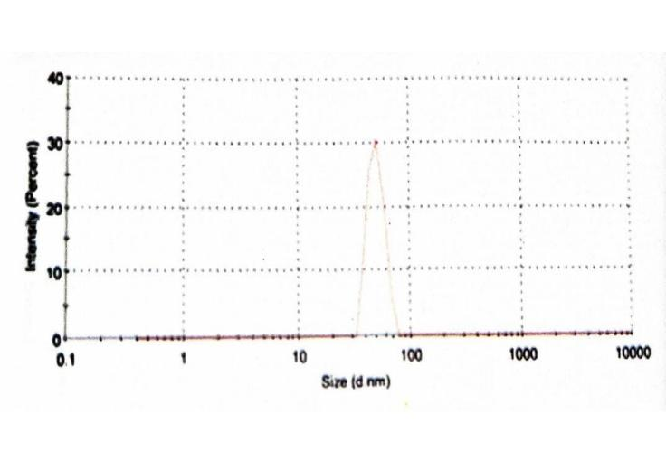

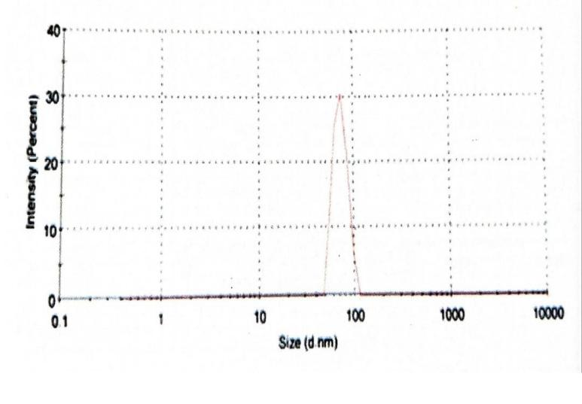

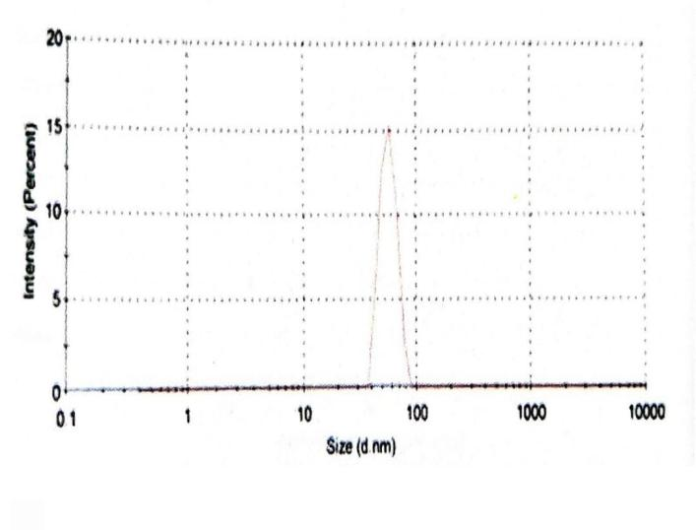

**Zeta potential of F6,F8 and F9**

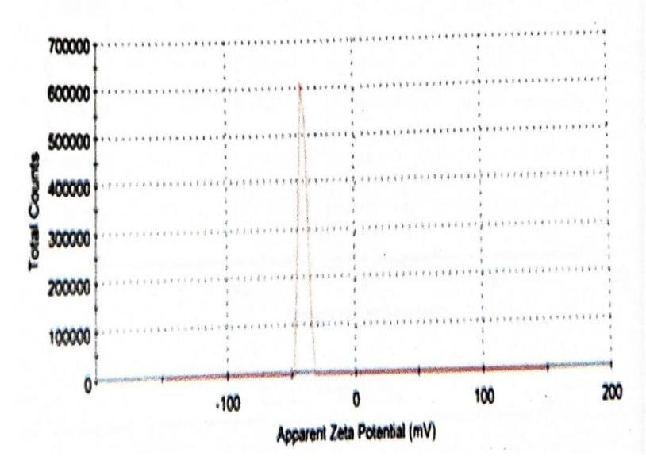

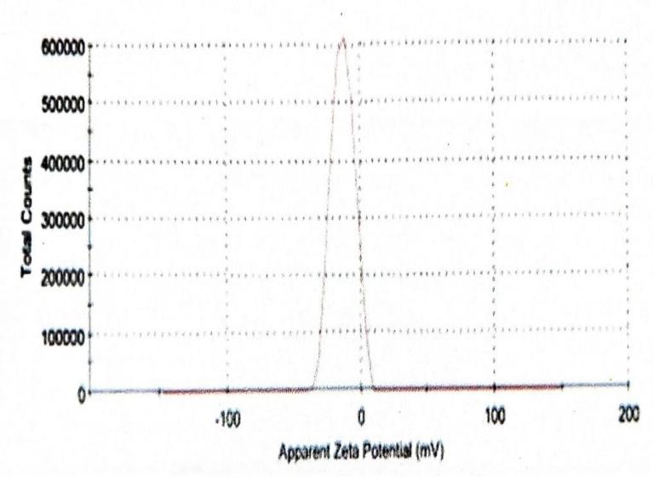

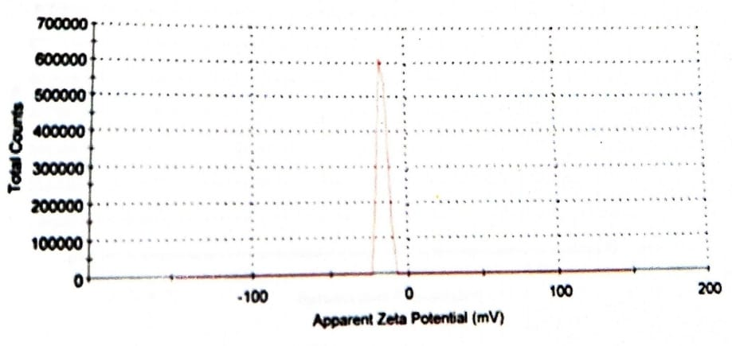

**Evaluation of optimized microemul based gels**

**Physical appearance of microemulgels containing metformin HCL**

|  |  |  |
| --- | --- | --- |
| **Formulation Code** | **Color** | **Homogeneity** |
| MEG-1[%w/w] | White | Excellent |
| MEG-2[%w/w] | White | Excellent |
| MEG-3[%w/w] | White | Excellent |

|  |  |
| --- | --- |
| **Microemulgels** | **pH** |
| MEG-1[%w/w] | 6.5±0.07 |
| MEG-2[%w/w] | 6.3±0.05 |
| MEG-3[%w/w] | 6.5±0.06 |

|  |  |
| --- | --- |
| **Microemulgels** | **Spreadability** |
| MEG-1[%w/w] | 20.80±0.08 |
| MEG-2[%w/w] | 20.70±0.05 |
| MEG-3[%w/w] | 20.75±0.07 |

|  |  |
| --- | --- |
| **Microemulgels** | **Homogeneity** |
| MEG-1[%w/w] | Good |
| MEG-2[%w/w] | Good |
| MEG-3[%w/w] | Good |

|  |  |
| --- | --- |
| **Microemulgels** | **Viscosity** |
| MEG-1[%w/w] | 1540±10 |
| MEG-2[%w/w | 1100±12 |
| MEG-3[%w/w] | 850±10 |

|  |  |
| --- | --- |
| **Microemulgels** | **Drug content[%]** |
| MEG-1[%w/w] | 87.50 |
| MEG-2[%w/w | 60.75 |
| MEG-3[%w/w] | 90.88 |

Mean cumulative percentage drug release